Part Number: PT938-47160-XX

Kit Contents
Item # | Quantity Reqd. | Description
1 | 1 | Molding, LH Front Door
2 | 1 | Molding, LH Rear Door
3 | 1 | Molding, RH Front Door
4 | 1 | Molding, RH Rear Door
Hardware Bag Contents
Item # | Quantity Reqd. | Description
1
2
Additional Items Required For Installation
Item # | Quantity Reqd. | Description
1
2
Conflicts
Recommended Tools
Personal & Vehicle Protection | Notes
Safety Glasses
Vehicle Protection
Special Tools | Notes
Roller | Hard Rubber Hand Roller, 1in to 3in wide.
Installation Tools | Notes
Flexible Scale or Tape Measure
Masking Tape | 1in wide
Clean Lint-free Cloths
Non-marring straight edge
Special Chemicals | Notes
VDC Approved Cleaner

General Applicability
Body Side Molding can be installed on all PRIUS models
Recommended Sequence of Application
Item # | Accessory
1 | Body Side Molding
2 | Door Edge Guard
*Mandatory
Vehicle Service Parts (may be required for reassembly)
Item # | Quantity Reqd. | Description
Legend
STOP: Damage to the vehicle may occur. Do not proceed until process has been complied with.
OPERATOR SAFETY: Use caution to avoid risk of injury.
CAUTION: A process that must be carefully observed in order to reduce the risk of damage to the accessory/vehicle and to ensure a quality installation.
TOOLS & EQUIPMENT: Used in Figures calls out the specific tools and equipment recommended for this process.
REVISION MARK: This mark highlights a change in installation with respect to previous issue.
SAFETY TORQUE: This mark indicates that torque is related to safety.

Care must be taken when installing this accessory to ensure damage does not occur to the vehicle. The installation of this accessory should follow approved guidelines to ensure a quality installation.

These guidelines can be found in the in Accessory Installation Practice document.

This document covers such items as:
- Vehicle Protection (use of covers and blankets, cleaning chemicals, etc.).
- Safety (eye protection, rechecking torque procedure, etc.).
- Vehicle Disassembly/Reassembly (panel removal, part storage, etc.).
- Electrical Component Disassembly/Reassembly (battery disconnection, connector removal, etc.).

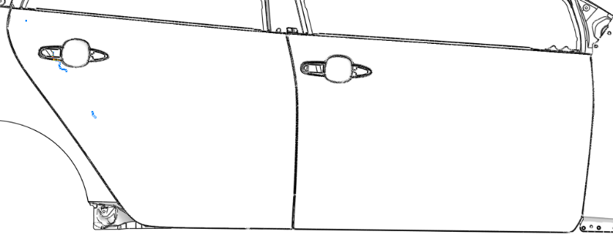
Please see your Toyota dealer for a copy of this document.
Fig. 1-1

Vehicle Preparation
  - Ensure vehicle is clean and properly prepped for body side molding installation
  - The work area, body side moldings, and vehicle door surface temperature must be a minimum of 16°C (60˚F) - 43°C°C (109˚F)
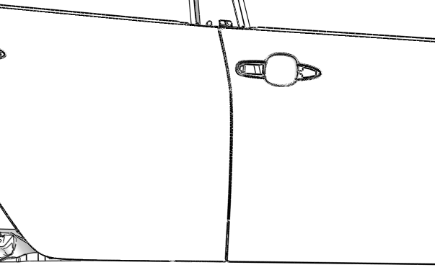
  - Saturate a clean lint-free cloth with VDC Approved Cleaner and clean the areas of each door as shown in (Fig. 1-1).
Fig. 2-1

When cleaning with VDC Approved Cleaner follow the manufacturer’s directions.
  - Wipe the cleaned surfaces with a clean, dry, lint-free cloth.
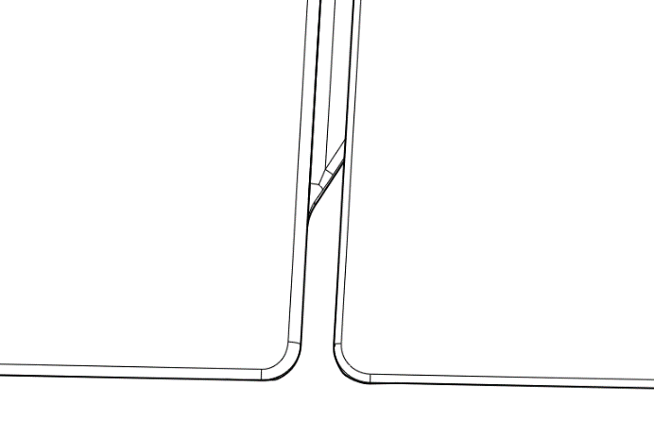
NOTE: Once cleaned do not contaminate this surface by touching it with your bare hands.
0.0
Fig. 2-2

Positioning Tape Application
  - Locate the rear curved edge on the front door (Fig. 2-1 & Fig. 2-2). All horizontal measurements will be provided from this location.
Fig. 2-2

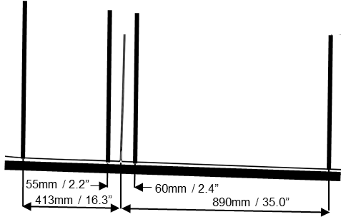
  - Measure 60mm (2.4in) forward and place a vertical piece of tape on the front door approximately 340mm (13.4in) long (Fig. 2-3) and (Fig. 2-4).
Fig. 2-3

  - Measure 890mm (35.0in) forward and place a vertical piece of tape on the front door approximately 307mm (12.1in) long (Fig. 2-3) and (Fig. 2-4).
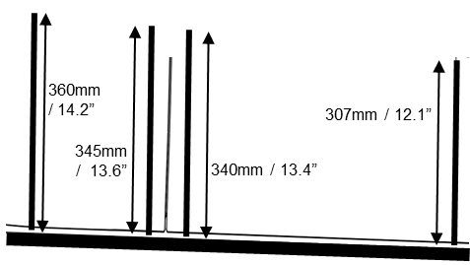
  - Measure 55mm (2.2in) rearward and place a vertical piece of tape on the rear door approximately 345mm (13.6in) long (Fig. 2-3) and (Fig. 2-4).
Fig. 2-4

  - Measure 413mm (16.3in) rearward and place a vertical piece of tape on the rear door approximately 360mm (14.2in) long (Fig. 2-3) and (Fig. 2-4).
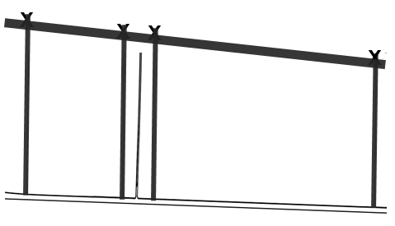
  - Mark the height dimensions on the vertical pieces of tape. Measurements are taken from the bottom edge of the door (Fig. 2-4).
Fig. 2-5
  - Apply a strip of tape along the length of the doors connecting the marks on the vertical pieces of tape. Ensure top edge of tape aligns with the marked locations on the vertical pieces of tape (Fig. 2-5).
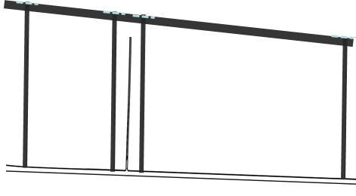
  - Trim the excess length on the vertical pieces of tape beyond the tape installed in step (g) (Fig. 2-6).
Fig. 2-6

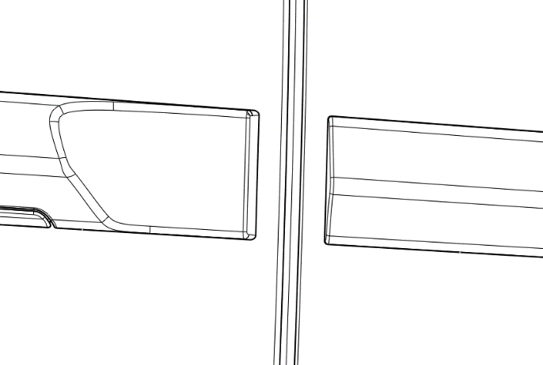
  - Mark the piece of tape applied in step (g) with a straight vertical line 8.0mm (0.3 in) ± 1.0mm (0.3 in) forward from the rear edge of the front door. (Fig. 3-1).
8.0mm / 0.31in
8.7mm / 0.34in
REAR DOOR
FRONT DOOR
REAR BSM
FRONT BSM
Fig. 3-1

  - Mark an additional vertical line on the same piece of tape 8.7mm (0.34in) ± 1.0mm (0.3 in) rearward from the front edge of the rear door. (Ensure the 8.0mm (0.3in) and 8.7mm (0.34in) minimum distances are carefully measured) (Fig. 3-1).
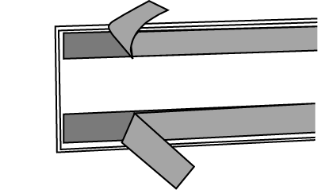
- Body Side Molding Installation.
Fig. 3-2

  - Carefully hold the front door molding by its edges and fold the liner tabs on the horizontal 3M tape lengths upwards (top piece) and downwards (bottom piece) such that the tabs are accessible when the molding is in install position (Fig. 3-2).
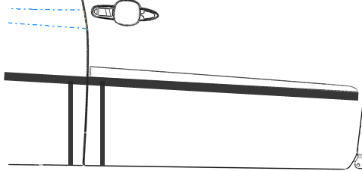
  - Align the rear edge of the front molding with the vertical mark on the tape located 8.0mm (0.3in) forward of the rear edge of the front door (Fig. 3-1).
Fig. 3-3

  - Align the bottom of the front molding flush with the top edge of the tape spanning the doors (Fig. 3-3).
  - Reposition as needed. Once properly aligned, carefully begin to expose tape by peeling away the liner starting from the rear of the molding and working forward.
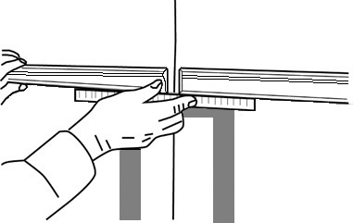
  - Repeat steps (a) to (d) for the front body side molding on the other side of the vehicle.
Fig. 3-4
Non-marring Straight Edge
  - Proceed to the rear body side molding and repeat step (a).
  - Align the front edge of the rear molding with the vertical mark on the tape located 8.7mm (0.34in) rearward of the front edge of the rear door (Fig. 3-1).
  - Place a non-marring straight edge flush with the bottom of the front molding. Then set the front edge of the rear molding on top of the straight edge. Edges must align (Fig. 3-4).
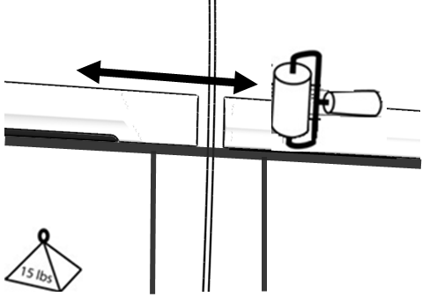
  - Once properly aligned, carefully begin to expose tape by peeling away the liner starting from the front of the molding and working rearward.
Fig. 3-5
Hand roller
  - Repeat steps (g) to (i) for the rear body side molding on the other side of the vehicle.
  - Use the hand roller and roll around the perimeter of the parts with a firm pressure to ensure complete adhesion of the tape to the door surface (Fig. 3-5).
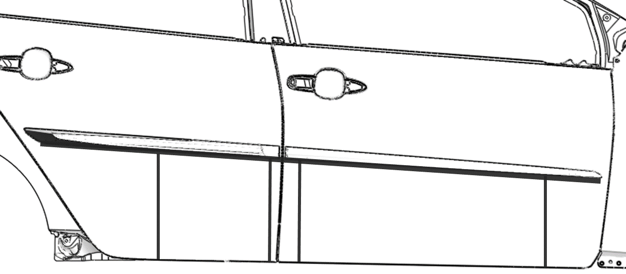
  - Remove and discard all tape strips (Fig 3-6).
Fig. 3-6

Accessory Function Checks
Check visual alignment

Check for proper tape adhesion.

Vehicle Function Checks
None Required

Vehicle Appearance Check
After accessory installation and removal of protective cover(s), perform a visual inspection.

The moldings should be visually straight.

Confirm 100% tape adhesion completely around the part between the Body Side Molding and door sheet metal.
No gap is allowed between the tape and the vehicle door surfaces, except where the tape seam joints on the backside.

Ensure no damage (including scuffs and scratches) was caused during the installation process.

